FROM: Nicole Crews / nicole.crews@apxexchange.com
These instructions do not constitute an order for time. Questions Regarding time purchase and/or Product allocations should be addressed to the media buyer or your station representative.
CLIENT: Lowes Home improvement
Notes:
*** TRAFFIC FOR ESTIMATES 2431,1431,431 ***
**Please remember to purge old Lowes radio spots that are no longer in flight**

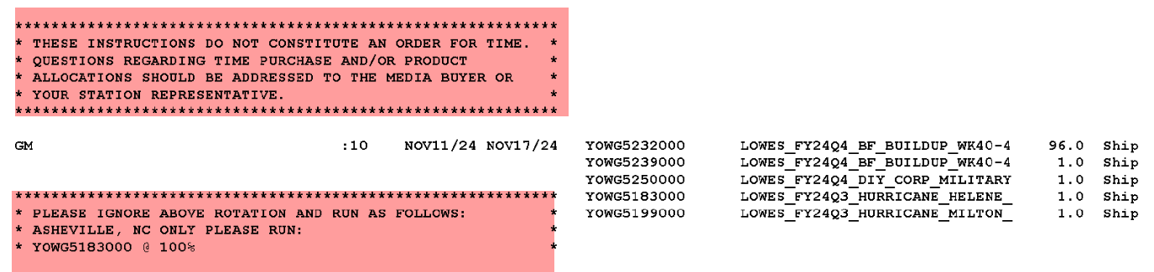

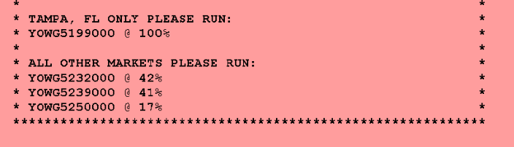

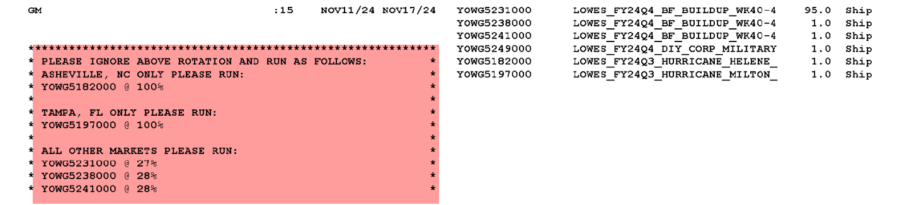

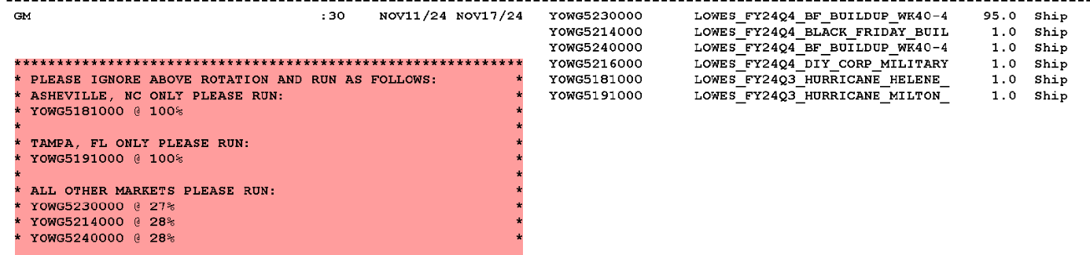

Asset links: Est.2431 - https://loweshomeimprovement.sharefile.com/d-s0565d6e889d04f3cb1f25cdea524fd02

END OF TRAFFIC

